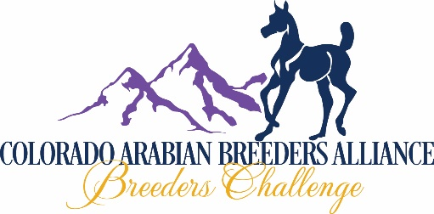
FUTURITY IN UTERO NOMINATION
2019 BREEDING (IN UTERO) FOR 2020 FOAL AND 2020 WEANLING COMPETITION

NOMINATION PERIOD: July 1, 2019 TO JANUARY 31, 2020

ONE NOMINATION PER FORM
PUREBRED: CHECK HERE [__] HALF ARABIAN: CHECK HERE [__]
NOMINATION FEE $50: CHECK HERE [__]

PLEASE COMPLETE THE IN UTERO NOMINATED FOAL REPORT WHEN YOUR FOAL IS BORN!

IF THIS IS A NOMINATION TRANSFER AS A RESULT OF NO LIVE FOAL FROM 2019 BREEDING: CHECK HERE [__] AND ATTACH THE IN UTERO NOMINATED FOAL REPORT FOR 2020 (MAIL TO DEBBIE HELMICK: NO ADDITIONAL FEE)

SIRE: | REGISTRATION# | BREED:
DAM: | REGISTRATION# | BREED:

NAME OF FOAL OWNER: ________________________________________________________________________
ADDRESS: ____________________________________________________________________________
CITY: _______________________________________ STATE: ______________ ZIP: ____________
PHONE: _____________________ EMAIL: ________________________________________________
FARM OR RANCH NAME: ________________________________________________________________________
WEB SITE: _____________________________________________________________________________________

NAME OF BREEDER: ____________________________________________________________________________
(IF NOT SAME AS OWNER)
ADDRESS: ____________________________________________________________________________
CITY: _______________________________________ STATE: ______________ ZIP: ____________
PHONE: _____________________ EMAIL: ________________________________________________
FARM OR RANCH NAME: ________________________________________________________________________
WEB SITE: _____________________________________________________________________________________

I, THE UNDERSIGNED, HAVE READ, UNDERSTAND, AND AGREE TO ABIDE BY, THE COLORADO ARABIAN BREEDERS ALLIANCE (CABA) CBC FUTURITY RULES AND REGULATIONS, AND THAT ALL ENTRIES MADE ON THIS FORM ARE TRUE AND CORRECT.

X_________________________________________________________________DATE_______________________
(OWNER OR AGENT SIGNATURE)
MAKE CHECKS PAYABLE TO COLORADO ARABIAN BREEDERS ALLIANCE (CABA)
CREDIT CARDS ACCEPTED: SEE PAGE 2 (BACK) OF THIS NOMINATION FORM
SEND YOUR NOMINATION (WITH ALL FEES) TO: CABA NOMINATIONS
C/O DEBBIE HELMICK
930 W WOLFENSBERGER RD
CASTLE ROCK, CO 80109

CREDIT CARDS ACCEPTED (4% SURCHARGE): (AMERICAN EXPRESS-DISCOVER-MASTERCARD-VISA)

NAME AS IT APPEARS ON CARD __________________________________________________________

C/C# _________________________________________________ BILLING STREET# ________________

EXP DATE __________/__________ SECURITY CODE __________ BILLING ZIP _____________________

X____________________________________________________ DATE: _______/_______/_______
(CARD HOLDER SIGNATURE)

EMAIL THIS FORM TO CABA4info@gmail.com IF USING C/C

