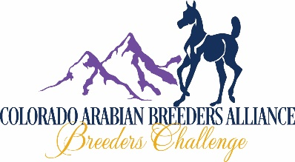

SPONSORSHIP OPPORTUNITIES

COLORADO STAKES RACE SPONSOR
MINIMUM OF $500 (INCREASES OF $100 INREMENTS)
AMOUNT OF YOUR SPONSORSHIP: $______________

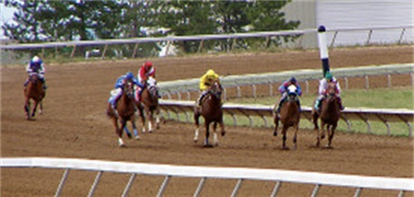

COLORADO ARABIAN BREEDERS ALLIANCE SPONSOR

SPONSOR NAME: _____________________________________ BUSINESS NAME: _________________________________________

ADDRESS: ___________________________________________ CITY: ________________________STATE: _______ ZIP: __________

PHONE: __________________________ EMAIL: _______________________________ WEB SITE: ____________________________

X____________________________________________________________________________DATE: ________/________/________
(SPONSOR SIGNATURE)
CHECKS PAYABLE TO: COLORADO ARABIAN BREEDERS ALLIANCE (CABA) ---------------------------- MAIL TO: CABA REGISTRAR
CREDIT CARDS ACCEPTED: CIRCLE YOURS: (AMERICAN EXPRESS---DISCOVER---MASTERCARD---VISA) C/O JIM GROMELSKI
(IF SUBMITTING WITH CREDIT CARD PAYMENT, MAY BE EMAILED TO: CABA4info@gmail.com) 35251 COUNTY RD 17
ELIZABETH, CO 80107
NAME AS IT APPEARS ON CARD _________________________________________________________________________________

C/C# ___________________________________________________________________ BILLING STREET# _____________________
(Street Number Only)
EXP DATE ____________/_____________ SECURITY CODE ___________________ BILLING ZIP ______________________________

X___________________________________________________________________ DATE: ___________/___________/__________
(CARD HOLDER SIGNATURE) Form 7c_Update 2019-06-04_jcg

